Lab 5: Adversarial Search – Minimax & Alpha-Beta Pruning
Lab Tasks 1, 2 and 3
Name: Ali Abbas | Roll No: 030
Lab Task 1: Trace the Supplied Tree by Hand Using Minimax

1. Objective
Hand-trace the Minimax algorithm (Section 5.1) on the supplied game tree, compute every node value bottom-up, determine the root value and best move, then verify the manual trace by running the code.

2. Supplied Input
scores = [3, 5, 2, 9, 0, 7]

The code computes treeDepth = ceil(log2(6)) = 3, so it needs 2³ = 8 leaves. It pads the list with two zeros:
scores = [3, 5, 2, 9, 0, 7, 0, 0]

Layers (root = depth 0, maxTurn starts True): Depth 0 = MAX, Depth 1 = MIN, Depth 2 = MAX, Depth 3 = leaves (terminal utilities).
Child rule: children of node i are 2i (left) and 2i+1 (right).

3. Game Tree
MAX (root) = 5
/ \
MIN = 5 MIN = 0
/ \ / \
MAX = 5 MAX = 9 MAX = 7 MAX = 0
/ \ / \ / \ / \
3 5 2 9 0 7 0* 0*
[0] [1] [2] [3] [4] [5] [6] [7]

* = padding leaves added by the code (not in original score list)

4. Manual Bottom-Up Trace

Step 1 – Depth 2 (MAX nodes): pick the larger child
Node | Children (leaves) | Calculation | Value
MAX-0 | scores[0], scores[1] = 3, 5 | max(3, 5) | 5
MAX-1 | scores[2], scores[3] = 2, 9 | max(2, 9) | 9
MAX-2 | scores[4], scores[5] = 0, 7 | max(0, 7) | 7
MAX-3 | scores[6], scores[7] = 0*, 0* | max(0, 0) | 0

Step 2 – Depth 1 (MIN nodes): pick the smaller child
Node | Children | Calculation | Value
MIN-0 | MAX-0, MAX-1 = 5, 9 | min(5, 9) | 5
MIN-1 | MAX-2, MAX-3 = 7, 0 | min(7, 0) | 0

Step 3 – Depth 0 (MAX root): pick the larger child
Node | Children | Calculation | Value
ROOT | MIN-0, MIN-1 = 5, 0 | max(5, 0) | 5

Result: Root value = 5. Best move for MAX = the LEFT branch (towards MIN-0), because it guarantees 5 while the right branch only guarantees 0.
Why 5? If MAX goes left, MIN chooses between 5 and 9 and will pick 5 (worse for MAX). If MAX goes right, MIN chooses between 7 and 0 and will pick 0. MAX therefore prefers 5 over 0.

5. Code (verification of the hand trace)
The original Section 5.1 code only prints the final value. I added a trace list so each node's calculation is printed, which lets me compare line-by-line with my hand trace. The Minimax logic itself is unchanged.
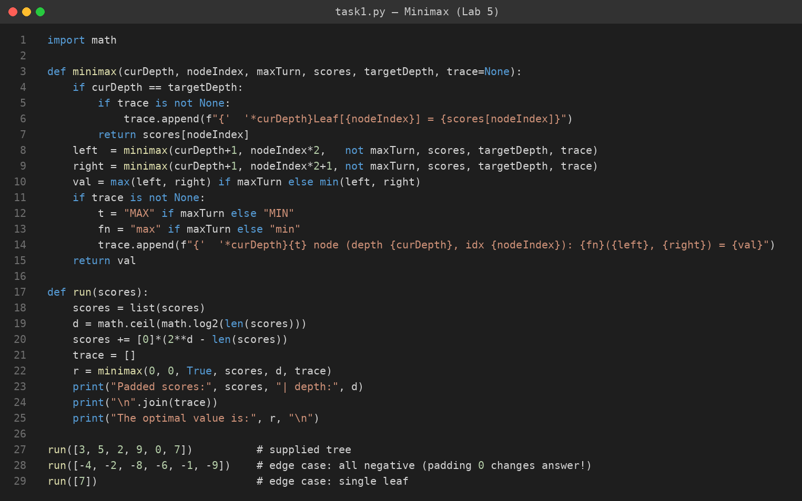
Screenshot 1: task1.py – Minimax with trace printing

6. Captured Output (supplied tree)
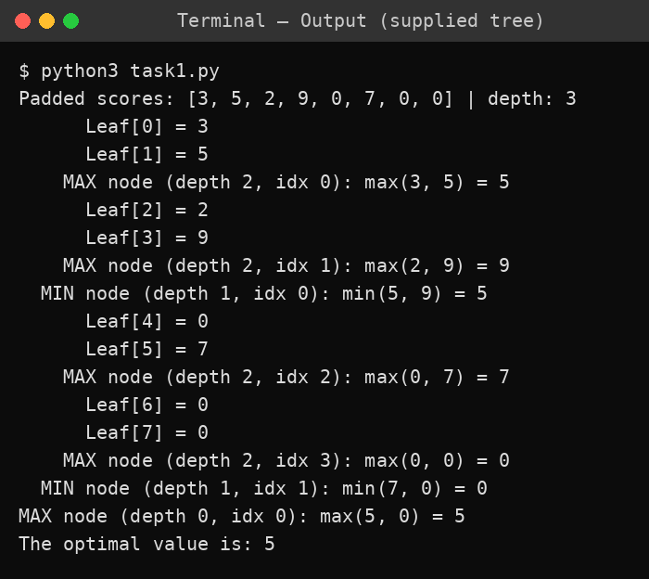
Screenshot 2: Terminal output for the supplied tree (root value = 5)

Match check: Every node value in the program output (5, 9, 7, 0 → 5, 0 → 5) is identical to my hand trace. ✔

7. Edge Cases / Limitation Analysis

Edge case A – Padding with 0 is not neutral (real limitation)
The supplied code pads missing leaves with 0. These are fake terminal nodes; they are not part of the real game. In the supplied tree, MIN-1 = min(7, 0) = 0 — that 0 comes from the padding leaf, not from a real outcome. The final answer (5) happens to survive because 5 > 0, but this is luck, not correctness.
Test with all-negative scores [-4, -2, -8, -6, -1, -9]:
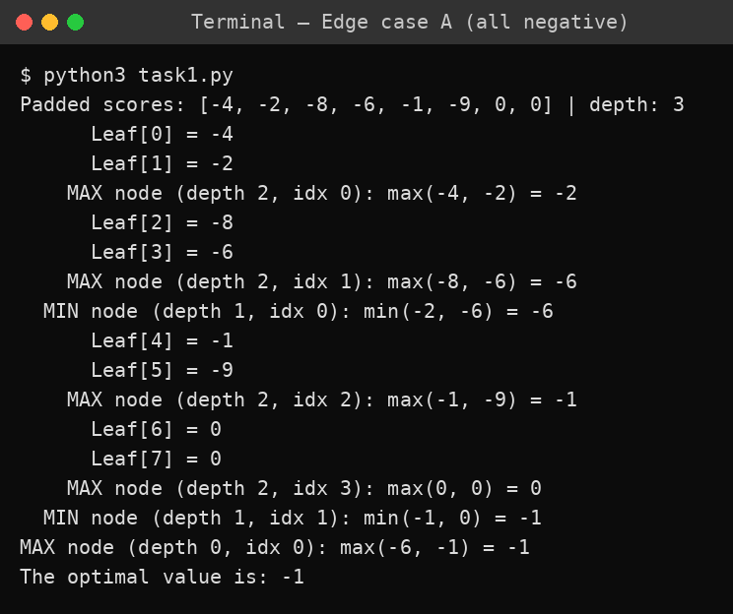
Screenshot 3: Edge case A – all-negative scores (the 0 leaves are padding)

Here the padding changes which branch looks best (the right branch wins with -1, only because fake 0-leaves exist). With the 6 real leaves only, the answer could differ. Conclusion: padding with 0 can silently distort the Minimax result; a better approach is to pad with a neutral value (e.g. -∞ for MAX-parent leaves / +∞ for MIN-parent leaves) or use a tree whose size is already 2ⁿ.

Edge case B – Single leaf
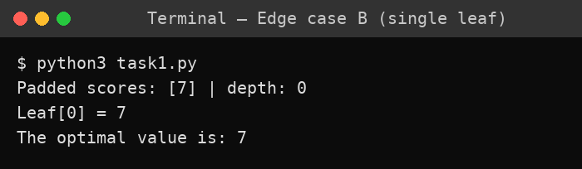
Screenshot 4: Edge case B – single leaf, output 7

The base case triggers immediately (curDepth == targetDepth), so the root value equals the only leaf. Works correctly.

8. Short Interpretation (link to Lecture Outcome)
- Minimax values are computed bottom-up: leaves are known utilities, MIN layers take the minimum, MAX layers take the maximum.
- MAX assumes MIN plays optimally (picks the worst result for MAX), so MAX guarantees at least the Minimax value (5) regardless of how MIN plays.
- Plain Minimax visited all 8 leaves (2³) – no pruning. This is the baseline that Alpha-Beta (Task 2/3) will be compared against.

9. Viva-Ready Answers
Q1. Why does MAX assume MIN picks the worst outcome for MAX? Because the game is zero-sum: whatever is good for MIN is bad for MAX. Assuming optimal opponent gives a guaranteed lower bound on the result.
Q2. Why is the tree depth ceil(log2(n))? A complete binary tree with 2ᵈ leaves has depth d; so d = ceil(log2(n)) is the smallest depth that holds n leaves.
Q3. Why pad the scores? The index formula (2i, 2i+1) needs a complete binary tree; without padding some indices go out of range. Padding is a shortcut with the side-effect shown in Edge Case A.
Q4. What is the time complexity? O(bᵈ) – here b = 2, d = 3 → 8 leaves visited.
Q5. Is the answer the value or the move? The value is 5; the action is 'go left' since the left child (MIN-0) carries that value.

10. Reflection
- What I learned: how alternating MAX/MIN layers propagate values from leaves to root.
- Real-AI use: turn-based game agents (chess, tic-tac-toe, checkers) with an evaluation function at a depth limit.
- What surprised me: the zero-padding silently created a fake MIN outcome of 0 in the supplied tree.
- What I'd do differently: avoid arbitrary padding, add the leaf counter early, and then compare against Alpha-Beta.
Lab Task 2: Add a Leaf-Evaluation Counter to Both Algorithms

1. Objective
Add a leaf-evaluation counter to both Minimax (Section 5.1) and Alpha-Beta (Section 5.2), run them on the same trees, and compare (a) the root value and (b) the number of leaves each one evaluates. This is the measurable outcome of the lab: same root value, and alpha-beta evaluates no more leaves than plain Minimax.

2. Approach and What I Changed
- Counter: a dictionary counter = {"leaves": 0} is passed into every recursive call. It is incremented only in the base case (depth == target), i.e. exactly when a terminal utility is read. A dict is used instead of a global variable because it is mutable, so all recursive calls update the same object and each run gets a fresh counter.
- Minimax: rewritten slightly (if/else with max/min) to take the extra counter argument. Logic is the same as 5.1.
- Alpha-Beta: logic is unchanged from 5.2 (including the alpha >= beta cut-off); only the counter argument and increment were added.
- Same tree for both: the compare() function runs both algorithms on the same score list, so the comparison is fair.
- Note: the 5.1 code pads missing leaves with 0. Here I give both algorithms already-complete trees (8 leaves), so the padded 0-leaves in Test 1 are counted like real leaves (see limitations).

3. Code
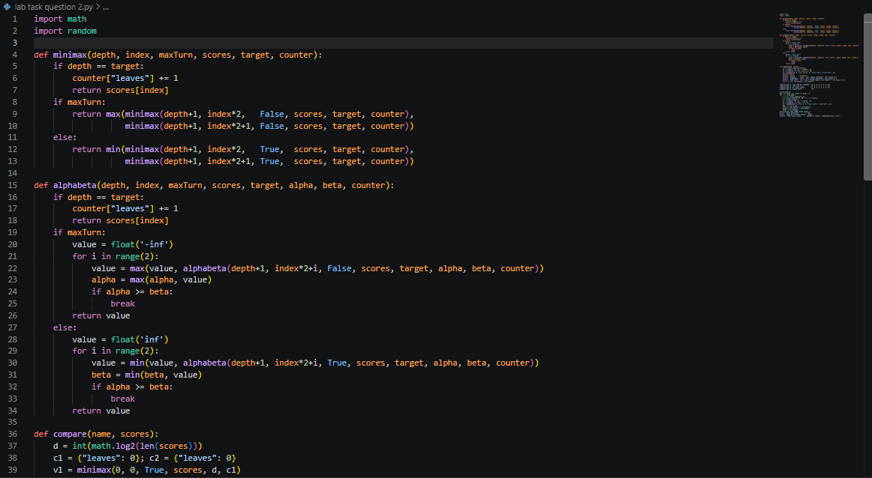
Screenshot 1: Code (part 1) – Minimax and Alpha-Beta with leaf counters (counter lines: 6 and 17)
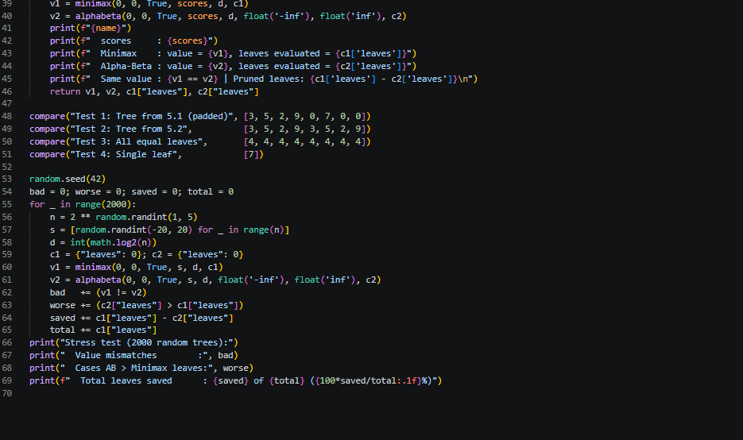
Screenshot 2: Code (part 2) – compare() driver, 4 tests and a 2000-tree stress test

4. Captured Output
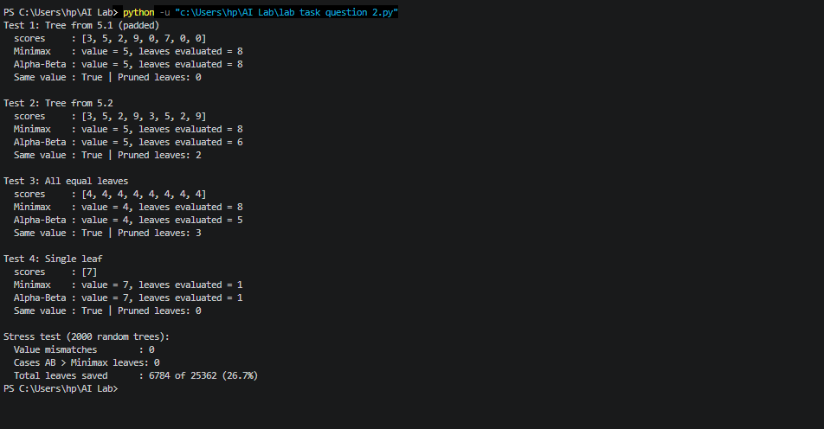
Screenshot 3: Terminal output of the program

5. Hand Verification of the Counts

5.1 Test 2 tree (scores = [3, 5, 2, 9, 3, 5, 2, 9]) – 6 leaves
MAX (root) = 5
/ \
MIN = 5 MIN = 5 <- cut-off (alpha 5 >= beta 5)
/ \ / \
MAX = 5 MAX = 9 MAX = 5 MAX [PRUNED]
/ \ / \ / \ / \
3 5 2 9 3 5 2x 9x
[0] [1] [2] [3] [4] [5] [6] [7]

x = leaf never evaluated (pruned). Evaluated leaves = 6 of 8.

Step | Node | alpha | beta | What happens | Leaves so far
1 | ROOT (MAX) | -inf | +inf | Go to left child MIN-0 | 0
2 | MAX-0 | -inf | +inf | Evaluate 3 (value 3), evaluate 5 (value 5). Return 5 | 2
3 | MIN-0 | -inf | 5 | beta = 5. Go to right child MAX-1 | 2
4 | MAX-1 | -inf | 5 | Evaluate 2 (value 2, alpha 2 < 5). Evaluate 9 (value 9, alpha 9 >= 5: cut-off true, but no child left to skip). Return 9 | 4
5 | MIN-0 | -inf | 5 | min(5, 9) = 5. Return 5 to root; root alpha = 5 | 4
6 | MAX-2 | 5 | +inf | Evaluate 3 (alpha stays 5), evaluate 5. Return 5 | 6
7 | MIN-1 | 5 | 5 | beta = min(inf, 5) = 5, so alpha 5 >= beta 5: BREAK. MAX-3 (leaves 2, 9) is PRUNED | 6
8 | ROOT (MAX) | 5 | +inf | max(5, 5) = 5 | 6

Result: Minimax = 8 leaves, Alpha-Beta = 6 leaves, both give 5. My hand count (6) matches the program output (6). ✔
Why MAX-3 can be skipped: MIN-1 already has a child worth 5. MIN can only lower that value, so MIN-1 will be at most 5. The root already has a guaranteed 5 from the left side, so the right side can never beat it. Looking at leaves 2 and 9 cannot change the answer.

5.2 Test 1 tree (scores = [3, 5, 2, 9, 0, 7, 0, 0]) – 8 leaves, nothing pruned
Left side is the same as above: 4 leaves, MIN-0 = 5, root alpha = 5. On the right side: MAX-2 has alpha = 5, beta = +inf, evaluates 0 then 7 (value 7). MIN-1 gets beta = 7, and alpha 5 < 7, so no cut-off. MAX-3 runs with alpha = 5, beta = 7; its first leaf is 0, giving value 0, which is nowhere near beta = 7, so the second leaf is also evaluated. Total = 8, same as Minimax. Alpha-beta did zero saving here.

6. Results Table
Test | Minimax leaves | Alpha-Beta leaves | Pruned | Same value?
1: [3,5,2,9,0,7,0,0] (5.1 tree, padded) | 8 | 8 | 0 | Yes (5)
2: [3,5,2,9,3,5,2,9] (5.2 tree) | 8 | 6 | 2 | Yes (5)
3: all leaves = 4 | 8 | 5 | 3 | Yes (4)
4: single leaf [7] | 1 | 1 | 0 | Yes (7)
Stress: 2000 random trees (depth 1-5) | 25362 total | 18578 total | 6784 (26.7%) | 0 mismatches

Measurable outcome check: alpha-beta never evaluated more leaves than Minimax (0 violations in 2000 random trees plus the 4 tests) and the root value matched every time. ✔

7. Edge Cases, Limitations and Failure Analysis
- Test 1 – pruning can be zero. Alpha-beta is not guaranteed to save work. On the 5.1 tree with this leaf order it evaluates all 8 leaves. Saving depends entirely on move ordering (this is exactly what Task 3 investigates).
- Test 3 – all-equal leaves. 5 leaves were evaluated. For a binary tree of depth 3, the theoretical minimum for alpha-beta is 2² + 2¹ − 1 = 5, so this is the best possible case. But it happened because ties trigger cut-offs (alpha >= beta uses >=), not because of clever ordering.
- Ties and cut-off on equality. Pruning on alpha == beta keeps the root value correct, but the pruned branch might have been an equally good alternative move. If you need all optimal moves, not just the value, >= pruning hides them.
- Test 4 – single leaf. Depth 0, so there is nothing to prune; both evaluate 1 leaf.
- Padding problem carried over from Task 1. In Test 1, leaves 6 and 7 are fake 0-leaves added by padding. They are counted in both algorithms, so the comparison is fair, but the tree itself is not a real game tree.
- Leaves are not total work. I counted only leaf evaluations. Alpha-beta still visits internal nodes and does alpha/beta comparisons, so 'fewer leaves' is not exactly 'proportionally faster'. In real games leaf evaluation (heuristic function) usually dominates the cost, so leaf count is still the standard measure.
- Tiny trees. With 8 leaves a 26.7% saving on random trees says little about real games. Real savings grow with depth and good ordering (best case roughly square-root of Minimax's leaf count); with bad ordering alpha-beta can degrade to the same count as Minimax, like Test 1. It cannot be worse in leaves, as the stress test confirmed.
- Stress test limits. Random integers in [-20, 20], seed 42, depth 1 to 5 – a sanity check of correctness, not a benchmark.

8. Short Interpretation (link to Lecture Outcome)
- Alpha-beta returns exactly the same Minimax value but may skip branches that provably cannot change the decision.
- alpha = best value MAX can already guarantee on the path to the root; beta = best value MIN can already guarantee. When alpha >= beta, the current node cannot influence the final decision, so remaining children are skipped.
- Pruning amount depends on ordering: Test 1 saved 0 leaves, Test 2 saved 2 leaves, on trees with the same size and similar values.

9. Viva-Ready Answers
Q1. Where did you put the counter and why there? In the base case only (depth == target), because a leaf evaluation is the moment a terminal utility is read. Counting at internal nodes would measure something else.
Q2. Why a dictionary and not a global variable? It is passed by reference so all recursive calls share it, and each run starts with a fresh one. A global would need manual resetting and breaks if two runs overlap.
Q3. Does pruning change the Minimax value? No. Pruned branches cannot affect the root value. My stress test confirms: 0 mismatches in 2000 trees.
Q4. What do alpha and beta mean? Alpha: best score MAX can guarantee so far along the current path. Beta: best score MIN can guarantee so far. If alpha >= beta the node is irrelevant to the decision.
Q5. Why did Test 1 prune nothing? The first leaves examined at each node never beat the bounds, so alpha never reached beta. Order was unfavourable for pruning.
Q6. Best case and worst case? Best case (perfect ordering) is about b^(d/2) leaves; for b = 2, d = 3 that is 5. Worst case equals plain Minimax: b^d = 8.
Q7. Does alpha-beta ever evaluate more leaves than Minimax? No. It follows the same traversal order and only skips children.

10. Reflection
- What I learned: how to measure the benefit of pruning instead of just claiming it, and that pruning is order-dependent.
- Real-AI use: in chess or checkers engines, leaf evaluation (heuristic) is expensive, so cutting leaf evaluations lets the agent search deeper in the same time.
- What surprised me: the 5.1 tree got zero pruning, while all-equal values reached the theoretical minimum of 5 leaves.
- What I would do differently: also count internal nodes, use larger trees, and test different orderings (Task 3).
Lab Task 3: Reorder Branches and Observe the Effect on Pruning

1. Objective
Reorder the branches of the game tree and observe that (a) the Minimax root value stays the same, and (b) the number of leaves Alpha-Beta evaluates changes. This answers the trigger question: why does move ordering affect pruning efficiency?

2. Approach
- What 'reordering' means: swapping the left and right child of any internal node. A depth-3 binary tree has 7 internal nodes, so there are 2⁷ = 128 possible orderings of the same tree. A depth-4 tree has 15 internal nodes, so 2¹⁵ = 32,768 orderings.
- Exhaustive, not cherry-picked: instead of trying 2 or 3 hand-picked orders, the program generates every ordering, runs Alpha-Beta on each, and records the root value and leaf count (using the counter from Task 2).
- Oracle ordering: for the best and worst case I also order children using their true Minimax values (MAX nodes: best child first; MIN nodes: lowest child first for best case; opposite for worst case). This needs the answer in advance, so it is a theoretical bound, not something a real agent can do.
- Trees tested: Tree A = 5.1 tree [3,5,2,9,0,7,0,0]; Tree B = 5.2 tree [3,5,2,9,3,5,2,9]; edge case all-equal [4]*8; and a random depth-4 tree with 16 leaves (seed 7).

3. Code
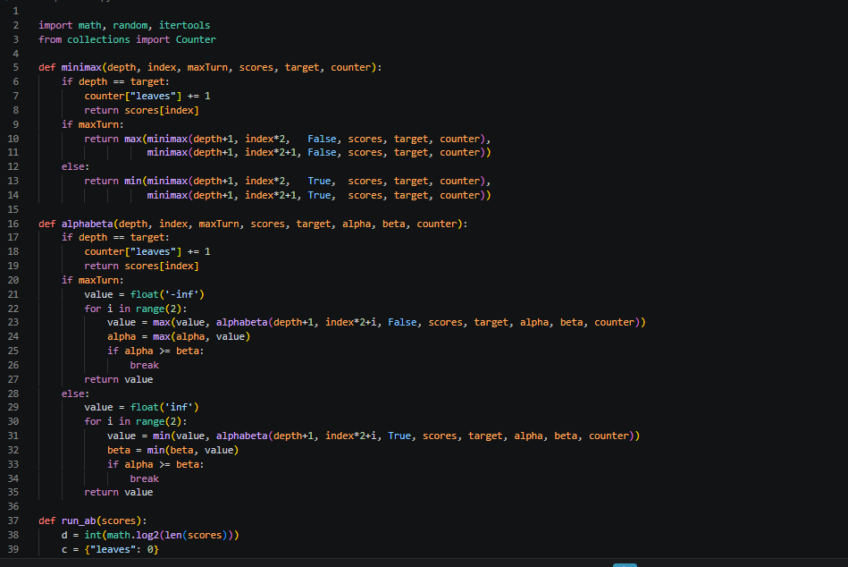
Screenshot 1: Code (lines 1-39) – Minimax and Alpha-Beta with leaf counters (same as Task 2)
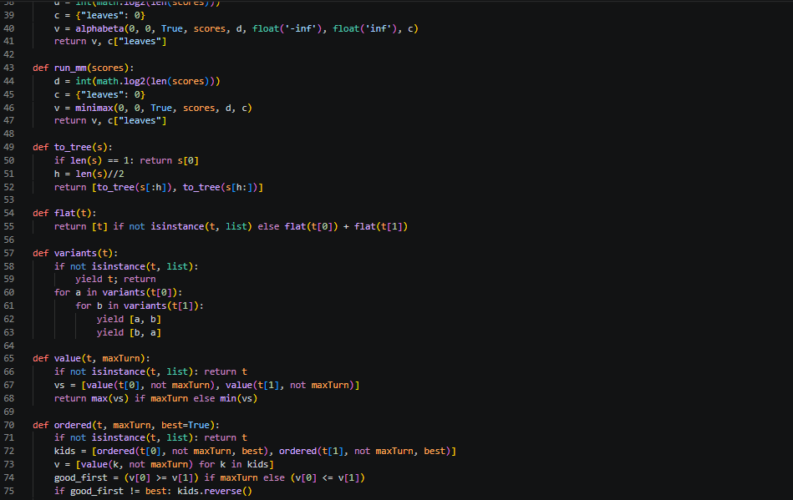
Screenshot 2: Code (lines 38-75) – run_ab, run_mm, tree conversion, all child-swap orderings, oracle ordering
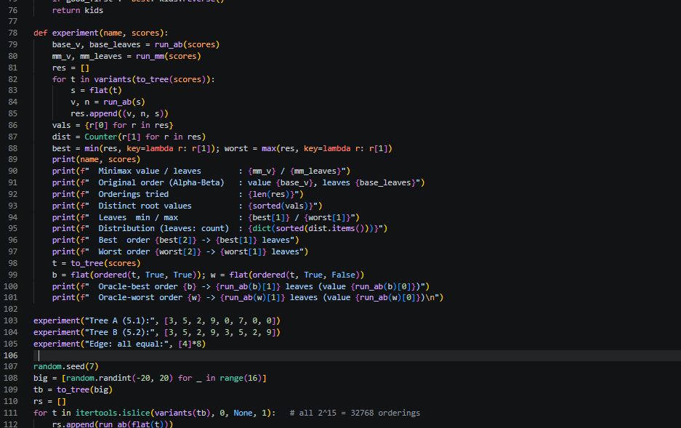
Screenshot 3: Code (lines 76-112) – experiment() and the three 3-level tests
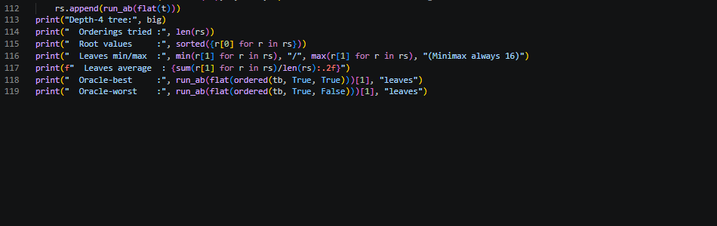
Screenshot 4: Code (lines 112-119) – depth-4 tree test and printed summary

4. Captured Output
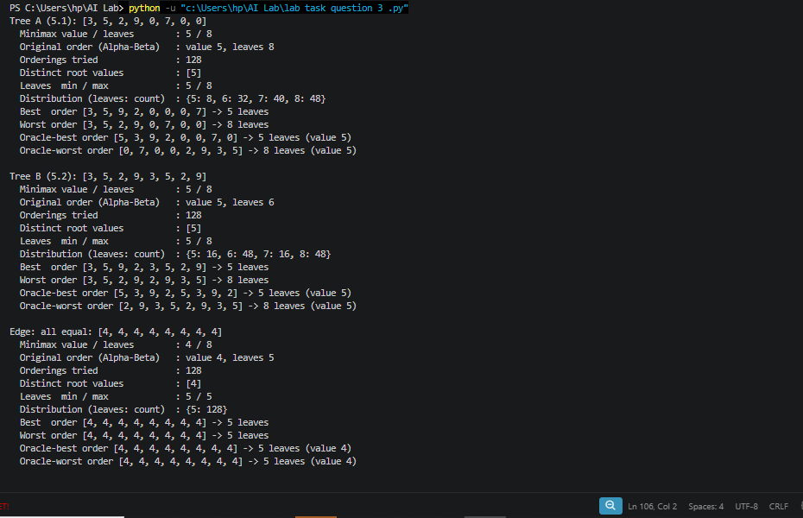
Screenshot 5: Terminal output for Tree A, Tree B and the all-equal edge case

5. Hand Verification

5.1 Tree A: same tree, two orders
Order | Leaf order | Alpha-Beta leaves | Minimax value
Original (from 5.1) | [3, 5, 2, 9, 0, 7, 0, 0] | 8 (no pruning) | 5
Best (oracle) | [5, 3, 9, 2, 0, 0, 7, 0] | 5 | 5

Tree A in the best order (the pruned leaves are marked x):
MAX (root) = 5
/ \
MIN = 5 MIN = 0 <- cut-off (alpha 5 >= beta 0)
/ \ / \
MAX = 5 MAX = 9 MAX = 0 MAX [PRUNED]
/ \ / \ / \ / \
5 3 9 2x 0 0 7x 0x
[0] [1] [2] [3] [4] [5] [6] [7]

Order: [5, 3, 9, 2, 0, 0, 7, 0] x = never evaluated. Evaluated leaves = 5 of 8.

Step | Node | alpha | beta | What happens | Leaves so far
1 | MAX-0 [5,3] | -inf | +inf | Evaluate 5 (value 5, alpha 5), evaluate 3. Return 5 | 2
2 | MIN-0 | -inf | 5 | beta = 5. Go to right child MAX-1 | 2
3 | MAX-1 [9,2] | -inf | 5 | Evaluate 9 (value 9, alpha 9 >= beta 5): BREAK. Leaf 2 PRUNED. Return 9 | 3
4 | MIN-0 | -inf | 5 | min(5, 9) = 5. Root alpha = 5 | 3
5 | MAX-2 [0,0] | 5 | +inf | Evaluate 0, evaluate 0 (alpha stays 5). Return 0 | 5
6 | MIN-1 | 5 | 0 | beta = 0, alpha 5 >= beta 0: BREAK. MAX-3 [7,0] PRUNED (2 leaves) | 5
7 | ROOT | 5 | +inf | max(5, 0) = 5 | 5

Why the order matters: in the original order, MIN-1 first looked at the strong child (MAX [0,7] = 7), so beta became 7 and stayed above alpha = 5, and nothing was cut. In the best order, MIN-1 looks at its weakest child first (value 0). That gives beta = 0, which is already below alpha = 5, so the other child is irrelevant and is skipped. The same logic cut leaf 2 under MAX-1.
Rule of thumb that falls out: at MAX nodes try the best (largest) child first; at MIN nodes try the best-for-MIN (smallest) child first. The earlier a strong bound appears, the more of the rest can be skipped.

5.2 Tree B
Original order [3,5,2,9,3,5,2,9] = 6 leaves (hand trace in Task 2). Best order [5,3,9,2,5,3,9,2] = 5 leaves: MAX-0 [5,3] evaluates 2 leaves, MAX-1 [9,2] evaluates 1 (9 >= beta 5, leaf 2 pruned), then MAX-2 [5,3] evaluates 2 and MIN-1 gets beta = 5 = alpha, so MAX-3 [9,2] is pruned. Total 2 + 1 + 2 = 5. Worst order [3,5,2,9,2,9,3,5] = 8 leaves: MIN-1 sees the strong child [2,9] = 9 first, beta = 9 > alpha = 5, and then [3,5] must also be fully read.

6. Results Table (all orderings)
Tree | Orig. leaves | Min | Max | Average | Orderings at min | Orderings at max (no saving)
A: 5.1 tree | 8 | 5 | 8 | 7.00 | 8 / 128 (6.25%) | 48 / 128 (37.5%)
B: 5.2 tree | 6 | 5 | 8 | 6.75 | 16 / 128 (12.5%) | 48 / 128 (37.5%)
All equal [4]*8 | 5 | 5 | 5 | 5.00 | 128 / 128 | 128 / 128
Depth-4 random | n/a | 7 | 15 | 11.69 | not counted | not counted

Root value across all orderings: Tree A: always 5. Tree B: always 5. All-equal: always 4. Depth-4 tree: always -7 over 32,768 orderings. Zero changes in total. Minimax plain always evaluates 8 (or 16) leaves, no matter the order. ✔
Measurable outcome: Alpha-Beta never evaluated more leaves than Minimax in any ordering (max was 8 of 8 and 15 of 16), and the root value never changed. ✔

7. Edge Cases, Limitations and Failure Analysis
- Ordering luck decides everything on these trees. For Tree A, only 8 of 128 orderings (6.25%) hit the best case, and 48 (37.5%) save nothing. The original order from the lab manual is one of those no-saving orderings, so the manual's 5.1 tree is a bad example of pruning.
- Oracle ordering is not realistic. To order children best-first I used the true Minimax values, which means I solved the problem before searching. Real engines use cheap guesses (for example previous-iteration results, captures first). I did not implement or test any of those, so I cannot claim how well they work.
- All-equal edge case. Every one of the 128 orderings gives 5 leaves, since ordering cannot matter when all values are the same. The 5 leaves is the depth-3 theoretical minimum 2² + 2¹ − 1.
- The worst case is not always full Minimax. On the depth-4 tree the worst ordering still saved 1 leaf (15 of 16). 'Worst case = Minimax' is an upper bound that a particular tree may not reach.
- Best case matches theory. Depth-4 best = 7 leaves = 2² + 2² − 1, versus 16 for Minimax (56% saved). Average over random orderings: 11.69 (27% saved). So good ordering roughly doubles the saving of an average one.
- Small trees only. 8 and 16 leaves; random leaf values; one depth-4 tree. The numbers show the effect but are not a benchmark. Real saving grows with depth, which I did not test.
- Only leaves counted. As in Task 2, internal-node visits are not measured.
- Tie / action caveat. Reordering moves subtrees to different positions, so the 'best move' must be identified by which subtree it leads to, not by index (left or right). With cut-offs on equality, tied alternatives can be hidden; here the root value is unique, so this did not matter.

8. Short Interpretation (link to Lecture Outcome)
- Reordering never changes the Minimax value: it only changes which branches are provably irrelevant by the time they are reached.
- Alpha-beta saves most when the strongest moves are searched first, because tight alpha/beta bounds appear early.
- Perfect ordering reduces leaves from b^d to about b^(d/2) (5 vs 8 at depth 3, 7 vs 16 at depth 4), which lets the search go roughly twice as deep in the same effort. Bad ordering gives no benefit (8 of 8).

9. Viva-Ready Answers
Q1. Does reordering change the Minimax result? No. max and min do not depend on the order of their arguments. Confirmed on 128 + 128 + 128 + 32,768 orderings with zero changes.
Q2. Why does ordering affect pruning? A cut-off needs alpha >= beta. A strong move early makes alpha larger (or beta smaller) sooner, so later siblings get cut. A weak move early leaves the bounds loose and nothing is cut.
Q3. What is the best ordering? MAX nodes: highest-value child first. MIN nodes: lowest-value child first. That gives about b^(d/2) leaves.
Q4. Can a real agent use this ordering? Not exactly, since it needs the true values. Practical engines approximate it with heuristics, I did not implement these.
Q5. Worst case? Leaf count equal to plain Minimax, b^d. Never more, since alpha-beta only skips.
Q6. Why was the lab's 5.1 tree a bad example? Its given order is among the 37.5% of orderings with zero pruning.
Q7. Why test all orderings? One or two hand-picked orders could mislead (best or worst luck). The full set shows the distribution: 8 best, 48 no-saving, average 7.0 leaves.

10. Reflection
- What I learned: pruning efficiency comes from ordering, not from the algorithm alone; the answer is identical, the work is not.
- Real-AI use: in game engines, good move ordering (and iterative deepening) is a big part of what makes alpha-beta practical.
- What surprised me: how rare the best ordering is (6.25%) and how common zero saving is (37.5%) on the same tree.
- What I would do differently: test cheap ordering heuristics instead of an oracle, use deeper trees, and count internal nodes and time.

